No. ADMIN/HR/RSU/CO-CERT/18 Karachi, Dated 15thMay, 2018

**Experience Certificate**

This is to certify that **Ms. Iqra Aslam** d/o Muhammad Aslam has served as an individual consultant -“Office Assistant in Admin/HR section” at Office of Reform Support Unit, School Education and Literacy Department, Government of Sindh from 02nd May, 2017 till 2nd April, 2018. The consultancy service of the Individual Consultant was selected for Sindh Education Sector Plan for Education project under World Bank Technical Assistance.

Her monthly consultancy remuneration is Gross PKR.Rs. 35,000/-

**Disclaimer:**

The Experience Certificate is issued at the specific request of the Individual Consultant, and in no case, entitle him/her for any claim of what so ever nature,for any benefit under Government of Sindh Service at any stage of her contract term and/or even after the expiry of the contract. This is issued on basis of the Consultancy Contract under World Bank Technical Assistance (TA) signed between two parties (RSU & the Individual Consultant).

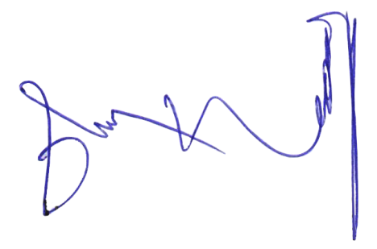

**(Muhammad Sheraz Kamal)** Senior Manager Admin HR &Logistics

Email: [sheraz.kamalrsu@gamil.com](mailto:sheraz.kamalrsu@gamil.com)

Copy for information:

1. Staff officer to Chief Program Manager, Reform Support Unit
2. Office Copy.